Bells Advertising Syndicates Site Manual

by



14th-Aug-2020

Contents

1 FTP Connect 2

1.1 Connect FTP 2

1.2 Media Image 3

1.2.1 Change Image 3

1.2.2 Media Text 4

1.3 Client logo 5

# FTP Connect

The File Transfer Protocol is a standard network protocol used for the transfer of computer files between a client and server on a computer network. FTP is built on a client-server model architecture using separate control and data connections between the client and the server.

Download and Install FTP Software from [**FILEZILLA**](https://filezilla-project.org/). (Download FileZilla Client All platforms)

## Connect FTP

Connect to your FTP account on the server. Start FileZilla and fill in the required fields for the FTP connection that you need as follows:

1. Open FileZilla.
2. Enter the address of the server in the field Host, located in the Quick connect bar. ...
3. Enter your username. ...
4. Enter your password. ...
5. Enter the port number. ...
6. Click on Quick connect or press Enter to connect to the server.
7. Click OK when you get a warning about an unknown host key.

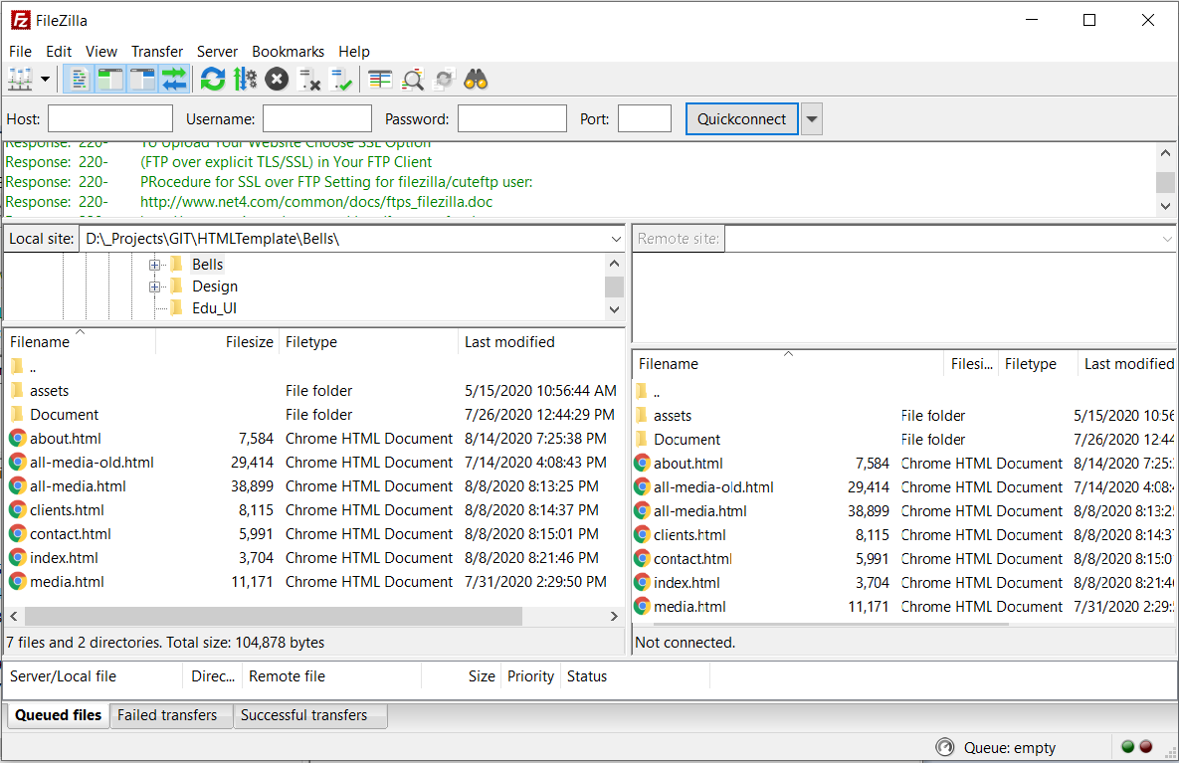

## Media Image

In FTP Folder you need to access the Image from path :**.\assets\img\**

**Image Size Should be: 1280*720**

Here is the image Folder and Image view.

|  |  |
| --- | --- |
|  |  |

### Change Image

In Media Page all images are categorized by Media type, with in category folder (e.g. \NeonSite, \Mobilevan), have a no of images named 1.jpg to ….. You need to upload new images from your local computer folder.

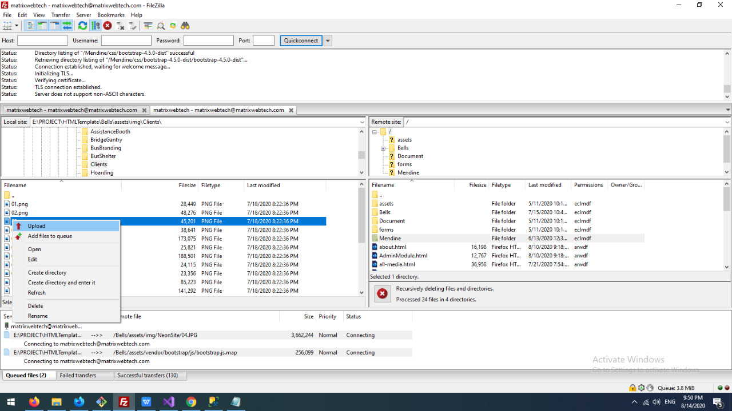

### Media Text

To alter media text you need to open all-media.html in a text editor like Nodepad++ (Download from <https://notepad-plus-plus.org/downloads/v7.8.8/>) .Open the Code here now Search by current text and add and save description. If No description currently has follow the step

1. Go to particular Tab by ID like (**" id="TrafficSignals)** for traffic Signal
2. For image Name (href="assets/img/TrafficSignals/01.jpg") add
3. **data-caption= “ YOUR NEW TEXT”**
4. **Save the Changed file of your local computer**
5. Connect FTP And Backup File (copy and paste)
6. Upload alter file via FTP and overwrite
7. Look in the Web site, Press CTRL+F5 for refresh

<div class="tab-pane fade row**" id="TrafficSignals**" role="tabpanel" aria-labelledby="TrafficSignals-tab">

<div class="row">

<div class="col-md-4 mb-0 p-0"><a data-fancybox="gallery" href="assets/img/TrafficSignals/01.jpg" **data-caption="**Traffic to and fro from Airport to Kolkata has to cross this crossing on VIP Road.This crossing is situated within 500 metres of Airport area. This is viewed by a _______ crowd. "><img class="card-img" src="assets/img/TrafficSignals/01.jpg" ></a></div>

<div class="col-md-4 mb-0 p-0"><a data-fancybox="gallery" href="assets/img/TrafficSignals/02.jpg" data-caption="This particluar crossing has the most important landmarks of Durgapur like Durgapur Municipal Corporation, Durgapur Court, Durgapur Development Authority Road leading towards City Center Bus Stop and to Junction Mall & Big Bazar. This is the main business hub of Durgapur."><img class="card-img" src="assets/img/TrafficSignals/02.jpg" ></a></div>

## Client logo

For client logo , path should be **\assets\img\Clients\**

**Image Size Should be: 300*180**

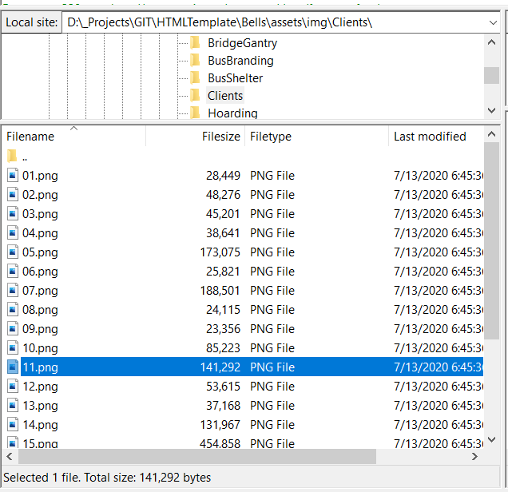

To change the client logo upload images with same name and allow overwrite.

THANK YOU